ASSIGNMENT 2_2
V.Harika
2303a510i0
Batch:30
Task 1:
Code & output:
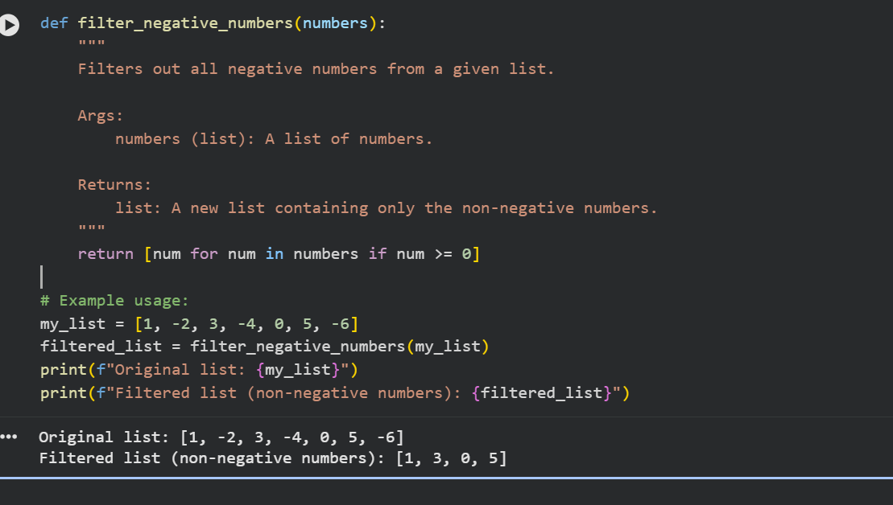
Justification:
Filtering out negative values ensures only valid sensor readings are processed, improving data reliability. This task highlights how AI can quickly generate simple yet useful functions for IoT applications. It demonstrates the importance of preprocessing before analysis.

Task 2:
Code & output:
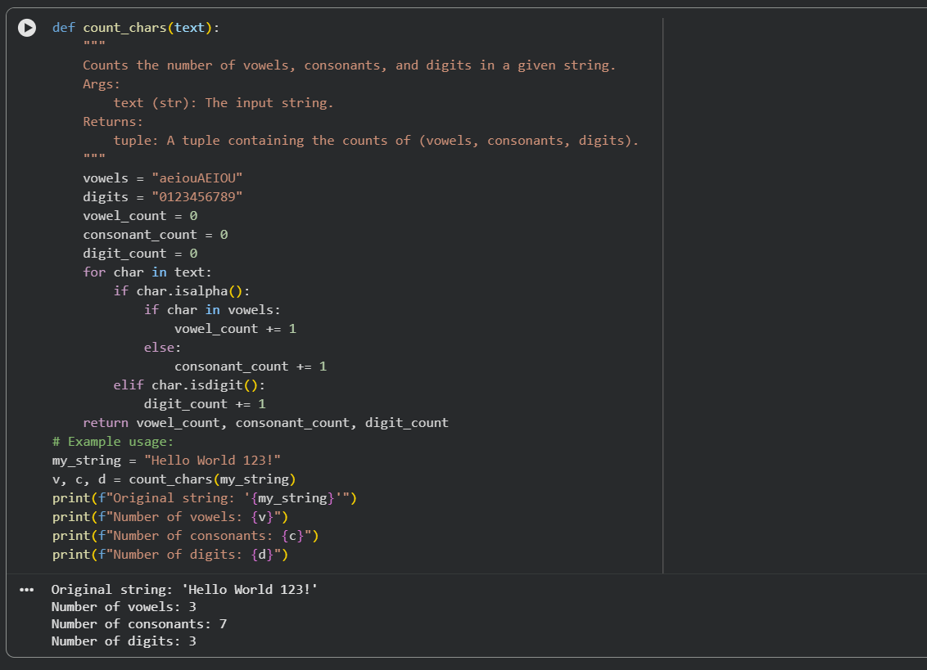
Justification:
Counting vowels, consonants, and digits builds a foundation for text analytics. AI-generated code helps automate repetitive logic and ensures accuracy. This task shows how Copilot/Gemini can simplify character classification while maintaining readability.

Task 3:
Code & output:
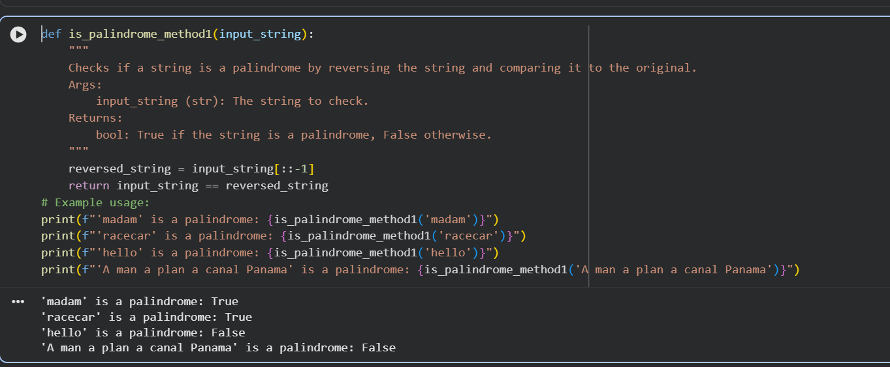
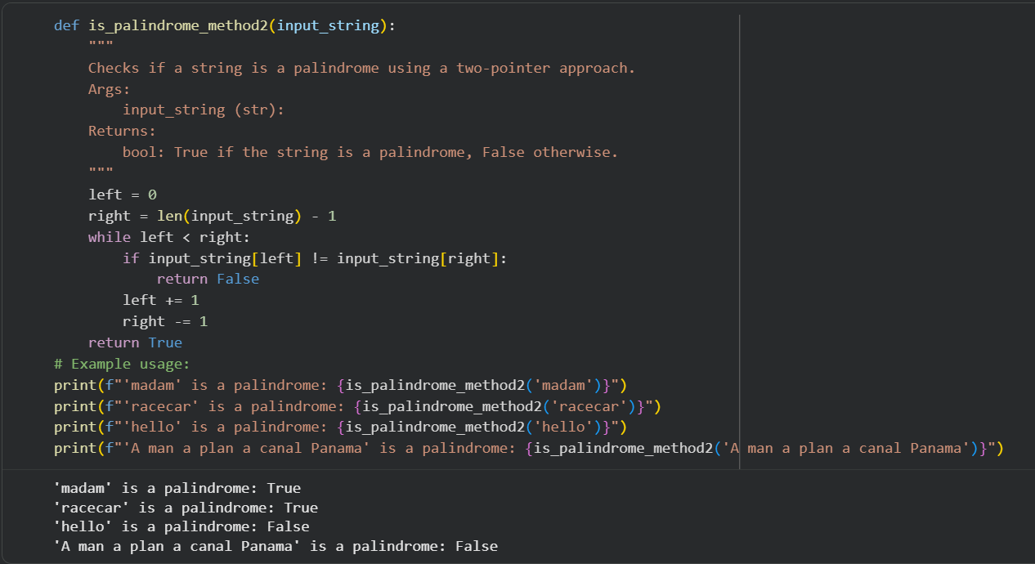
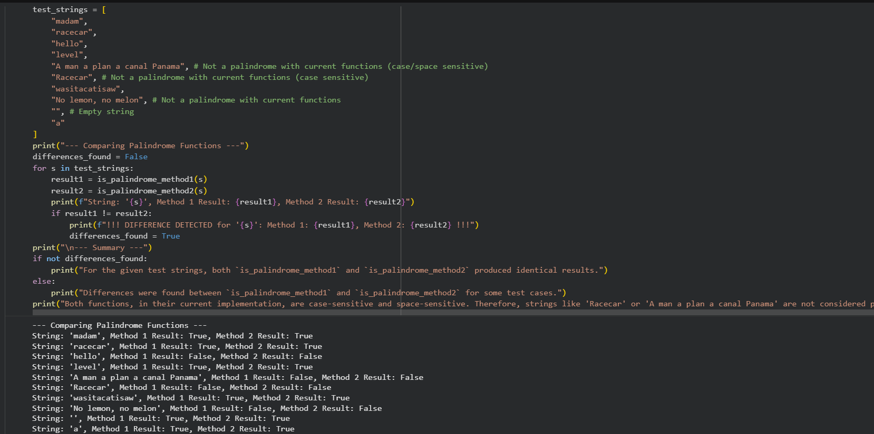
Justification:
Comparing outputs from Gemini and Copilot reveals differences in clarity, structure, and coding style. This task emphasizes how multiple AI tools can solve the same problem but with varying readability. It helps developers choose the most suitable tool for their workflow.
Task 4:
Code & output:
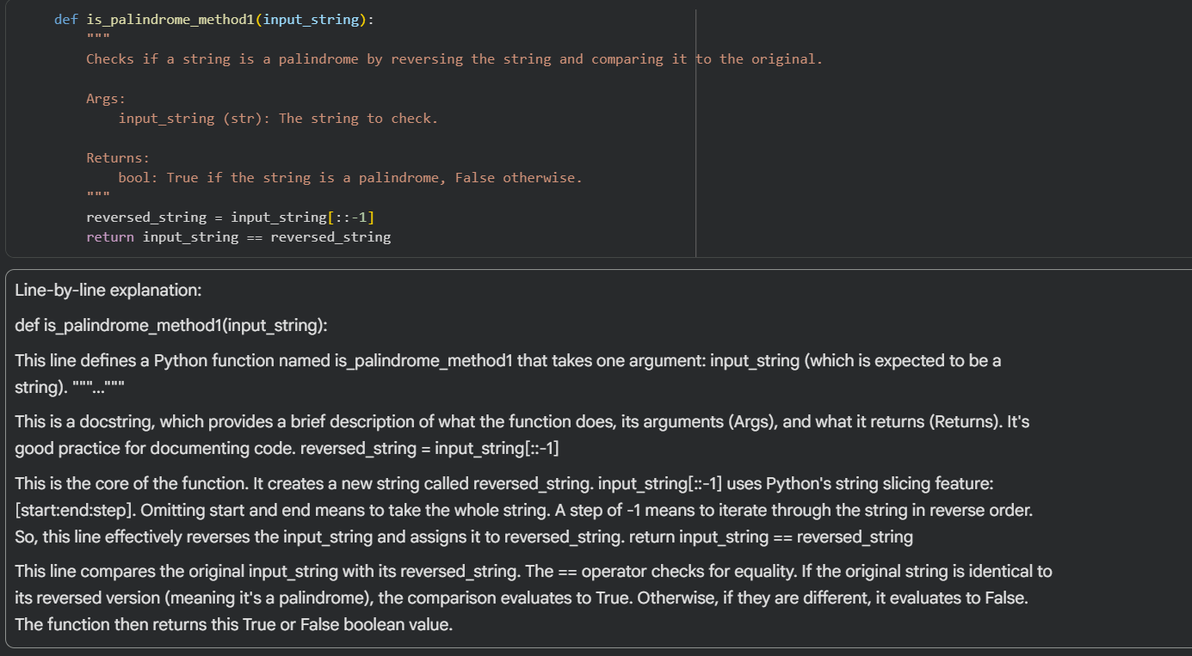
Justification:
AI explanations make unfamiliar code easier to understand by breaking it down line by line. This improves learning and debugging efficiency. The task demonstrates how AI can act as a teaching assistant, bridging gaps in comprehension for students and developers.

